**Insert School Logo**

**Semester Two**

**Examination 2020**

**Question/Answer booklet**

**MATHEMATICS**

**SPECIALIST UNITS 3 & 4**

**Section One:**

**Calculator-free**

|  |
| --- |
| Student Name: _____________________________________ |
| Teacher’s Name: _____________________________________ |
|  |

**Time allowed for this section**

Reading time before commencing work: five minutes

Working time for paper: fifty minutes

**Material required/recommended for this section**

**To be provided by the supervisor**

This Question/Answer booklet

Formula Sheet

**To be provided by the candidate**

Standard items: pens (blue/black preferred), pencils (including coloured), sharpener, correction tape/fluid, erasers, ruler, highlighters

Special Items: nil

**Important note to candidates**

No other items may be taken into the examination room. It is **your** responsibility to ensure that you do not have any unauthorised notes or other items of a non-personal nature in the examination room. If you have any unauthorised material with you, hand it to the supervisor **before** reading any further.

**Structure of this paper**

|  |  |  |  |  |  |
| --- | --- | --- | --- | --- | --- |
|  | Number of questions available | Number of questions to be attempted | Working time (minutes) | Marks available | Percentage of exam |
| **Section One**  **Calculator—free** | **8** | **8** | **50** | **53** | **35** |
| Section Two  Calculator—assumed | 12 | 12 | 100 | 97 | 65 |
|  | | | |  | 100 |

**Instructions to candidates**

1. The rules for the conduct of Western Australian external examinations are detailed in the

*Year 12 Information Handbook 2020.* Sitting this examination implies that you agree to abide by these rules.

1. Answer the questions according to the following instructions.

**Show all your working clearly.** Your working should be in sufficient detail to allow your

answers to be checked readily and for marks to be awarded for reasoning. Incorrect answers given without supporting reasoning cannot be allocated any marks. For any question or part question worth more than two marks, valid working or justification is required to receive full marks. If you repeat an answer to any question, ensure that you cancel the answer you do not wish to have marked.

It is recommended that you **do not use pencil**, except in diagrams.

1. You must be careful to confine your responses to the specific questions asked and to follow any instructions that are specific to a particular question.
2. Spare pages are included at the end of this booklet. They can be used for planning your responses and/or as additional space if required to continue an answer.

* Planning: If you use the spare pages for planning, indicate this clearly at the top of the page.
* Continuing an answer: If you need to use the space to continue an answer, indicate in the original answer space where the answer is continued, i.e. give the page number. Fill in the number of the question that you are continuing to answer at the top of the page.

1. The Formula Sheet is **not** handed in with your Question/Answer Booklet.

# Section One: Calculator–free 35% (53 marks)

This section has **eight (8)** questions. Attempt **all** questions. Write your answers in the spaces provided.

Working time: 50 minutes

$$\int_{0}^{\frac{π}{3}}{\sec{θ}\tan{θ}dθ}.$$

**Question 1 (4 marks)**

Use the substitution $u=\sec{θ}$ to evaluate

(4 marks)

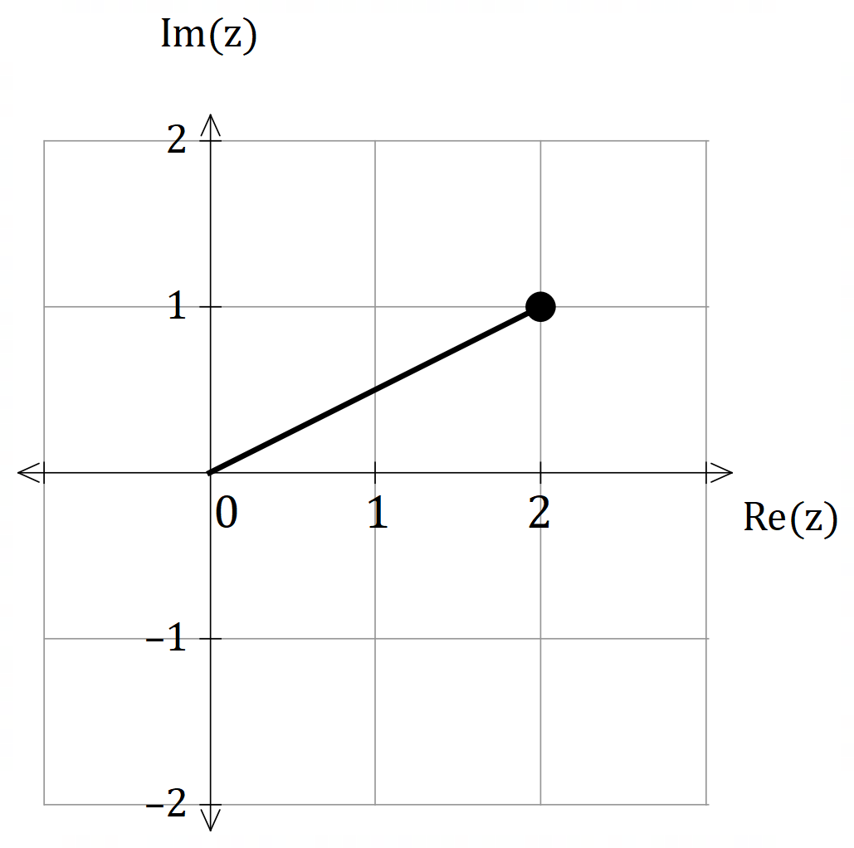**Question 2 (5 marks)**

The diagram shows one of the roots of the complex polynomial:

$$P\left(z\right)=z^{4}-6z^{3}+18z^{2}-30z+25$$

Use this information to find all the solutions to $P\left(z\right)=0$.

(5 marks)

**Question 3 (5 marks)**

Use partial fractions to show that:

$$\int_{1}^{2}{\frac{2x^{2}+1}{x^{3}+x}}dx=\ln{\sqrt{10}}$$

(5 marks)

**Question 4 (10 marks)**

Consider the functions: $f\left(x\right)=x^{2}+2x-3$ and $g\left(x\right)=-\left|x\right|$ for their natural domains.

(a) Determine $f∘g\left(x\right)$ and state its domain and range.

(3 marks)

(b) Sketch the graph of $f∘g\left(x\right)$ on the axes provided below clearly indicating all of its

graphical features. (3 marks)

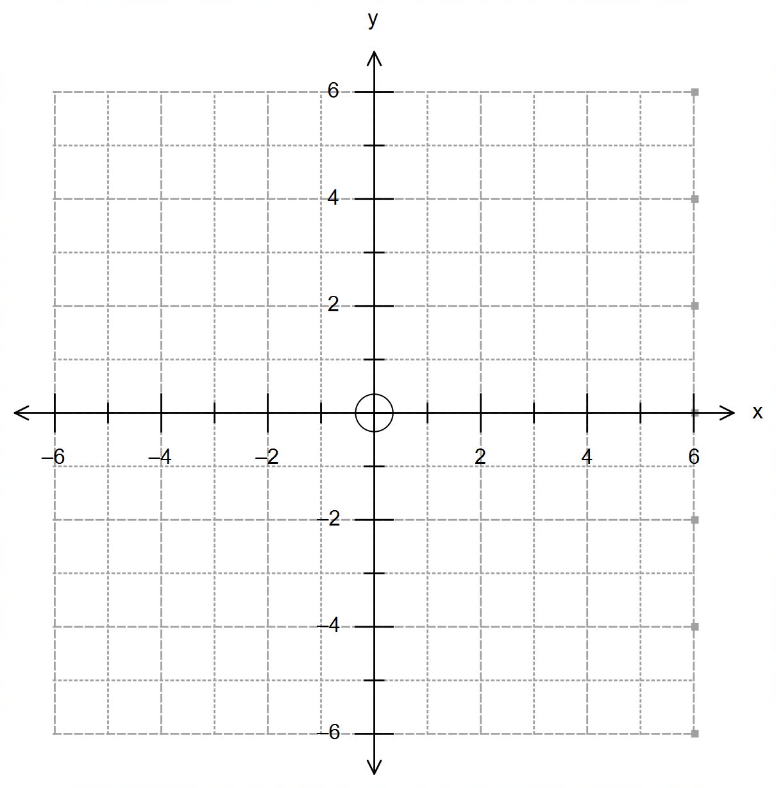

**(Question 4 – Continued)**

The inverse function $f^{-1}(x)$ exists for the condition $x≥k$.

(c) Determine the minimum value of $k$ and state the function $f^{-1}(x)$. (2 marks)

(d) Using your answer in (c), determine:

(i) $g∘f^{-1}\left(0\right)$ (1 mark)

(ii) $g∘f∘f^{-1}\left(x+1\right)$ (1 mark)

**Question 5 (9 marks)**

Consider the region $R$ in three-dimensional space defined by $\left|r-i-j\right|≤3$.

(a) State the shape and characteristics of this region, and determine the maximum

possible value of $\left|r\right|$. (3 marks)

(b) Describe the locus of all points defined by the intersection of $R$ and the xz plane,

and state its mathematical definition. (2 marks)

**(Question 5 – Continued)**

(c) Show that the line $r=\left(5+λ\right)i+2j-λk$, $λ∈R$, is tangent to $R$, and state the

coordinates of the point of tangency. (4 marks)

**Question 6 (9 marks)**

The graph of $\left|f\left(x\right)\right|$ and $f\left(\left|x\right|\right)$ are shown below, where $f\left(x\right)$ is a continuous function defined

for the domain $-5<x≤4$.

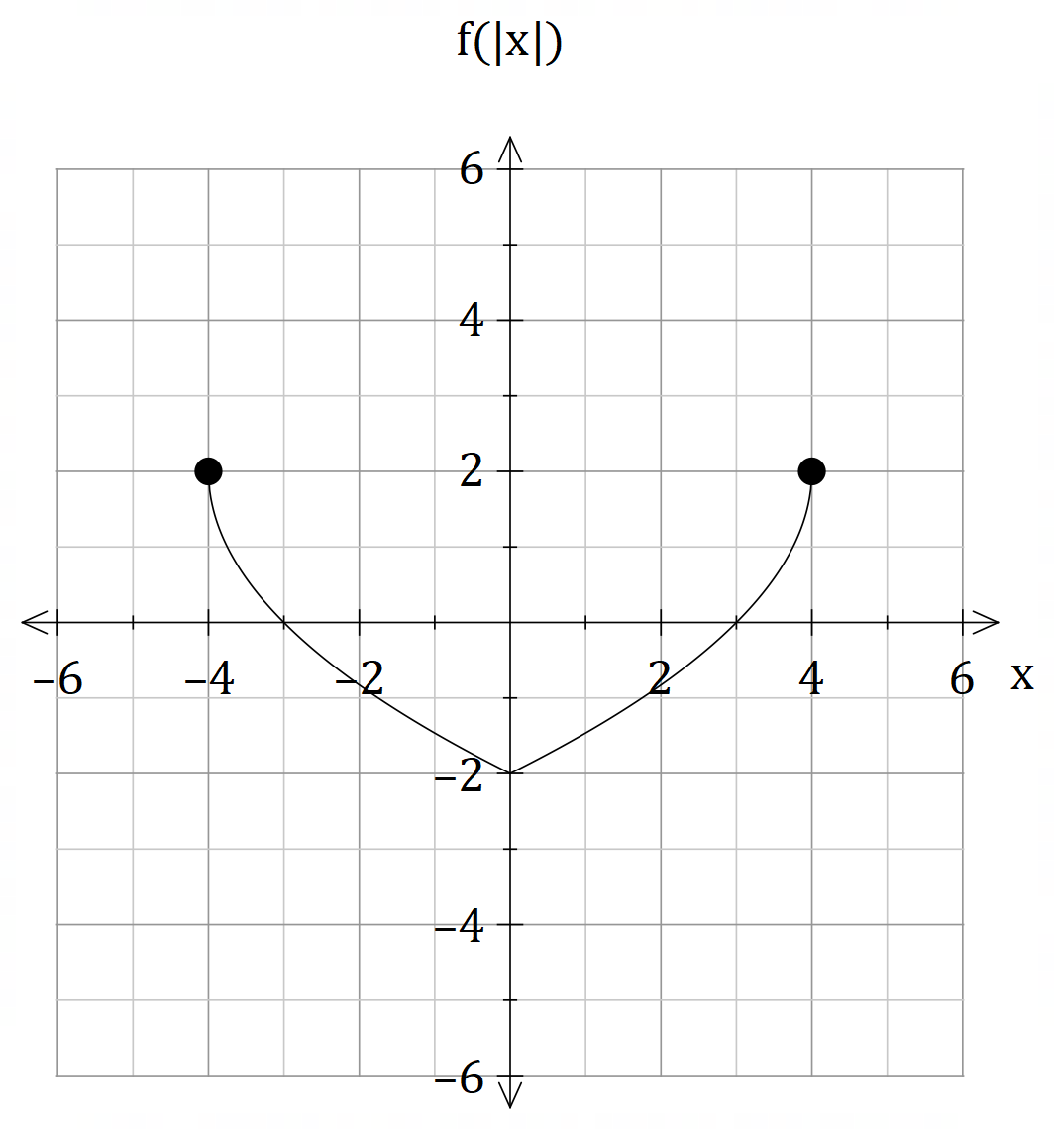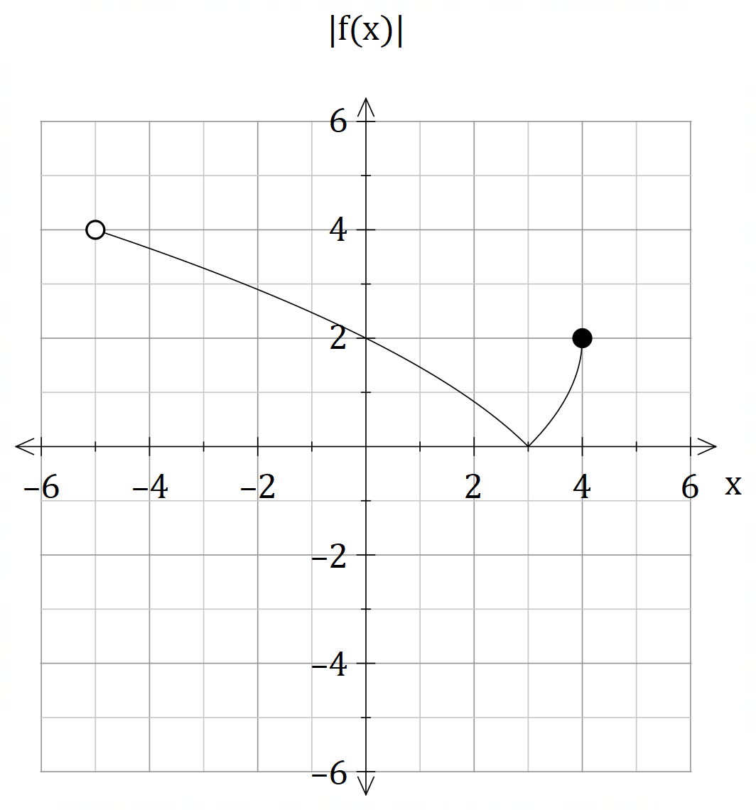

(a) Use the axes below to sketch $-f\left(x\right)$ and $f\left(-\left|x\right|\right)$ (4 marks)

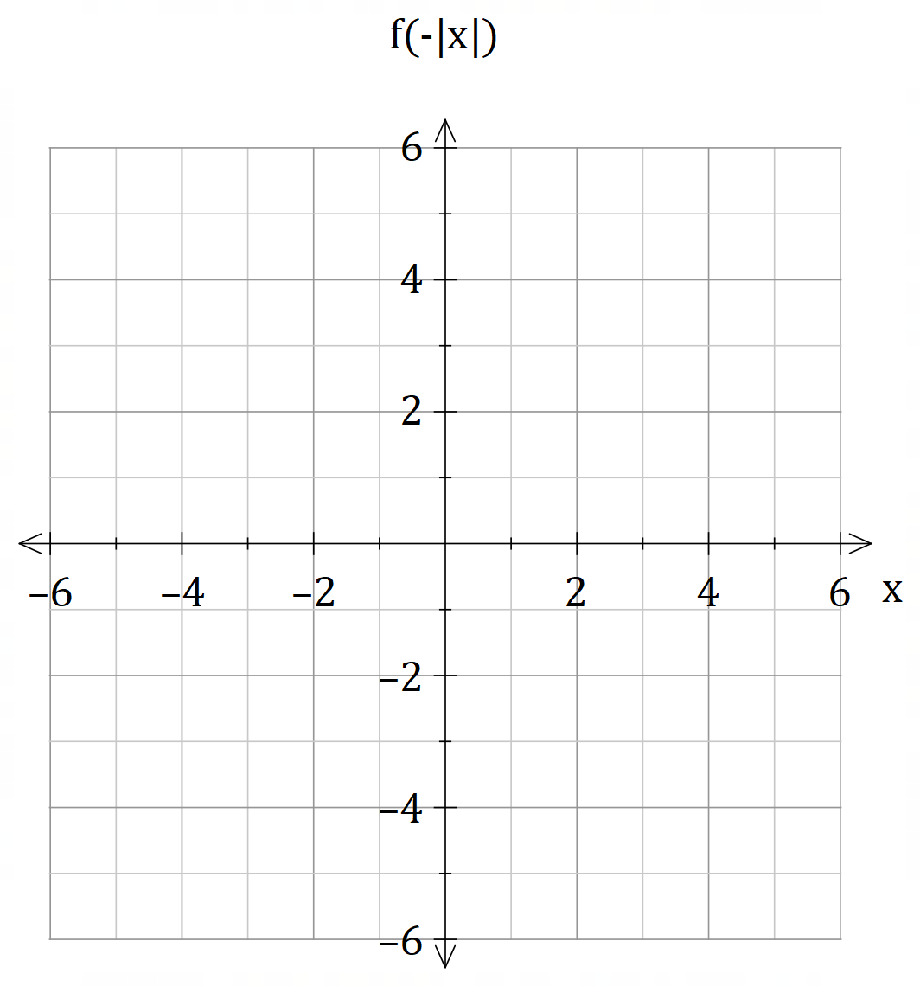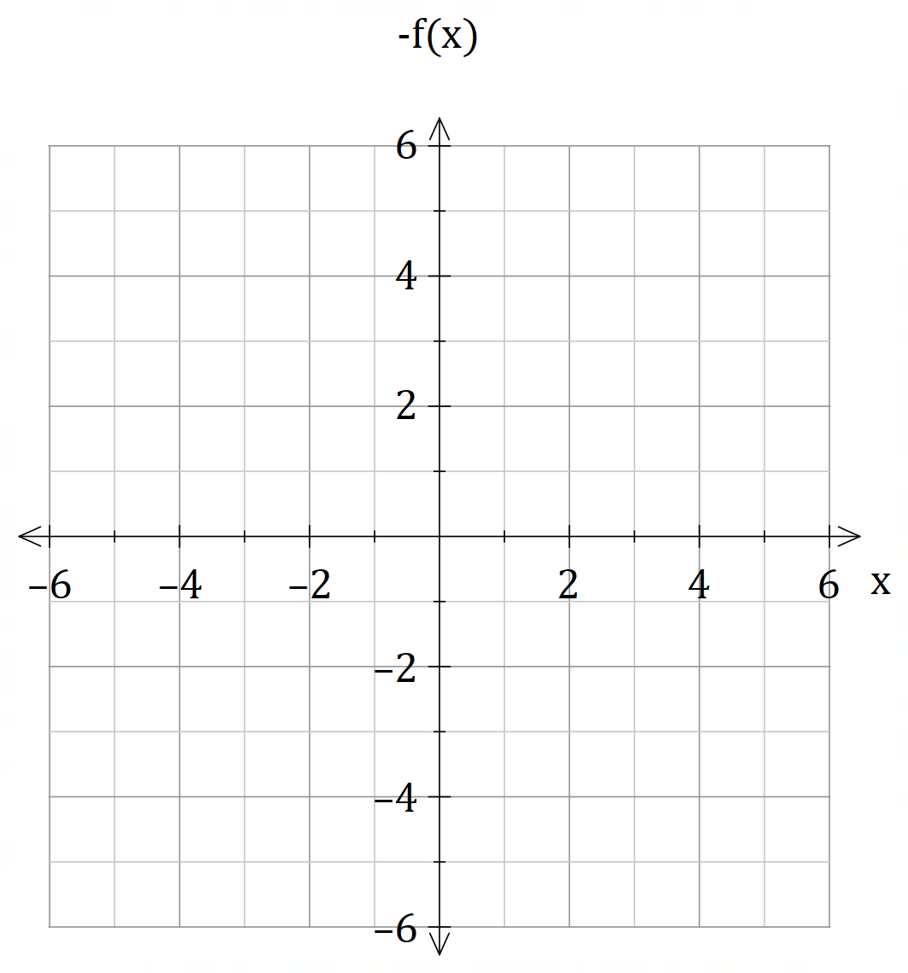

**(Question 6 – Continued)**

(b) Sketch the graph of $\frac{1}{f\left(\left|x\right|\right)}$ on the axes below. (3 marks)

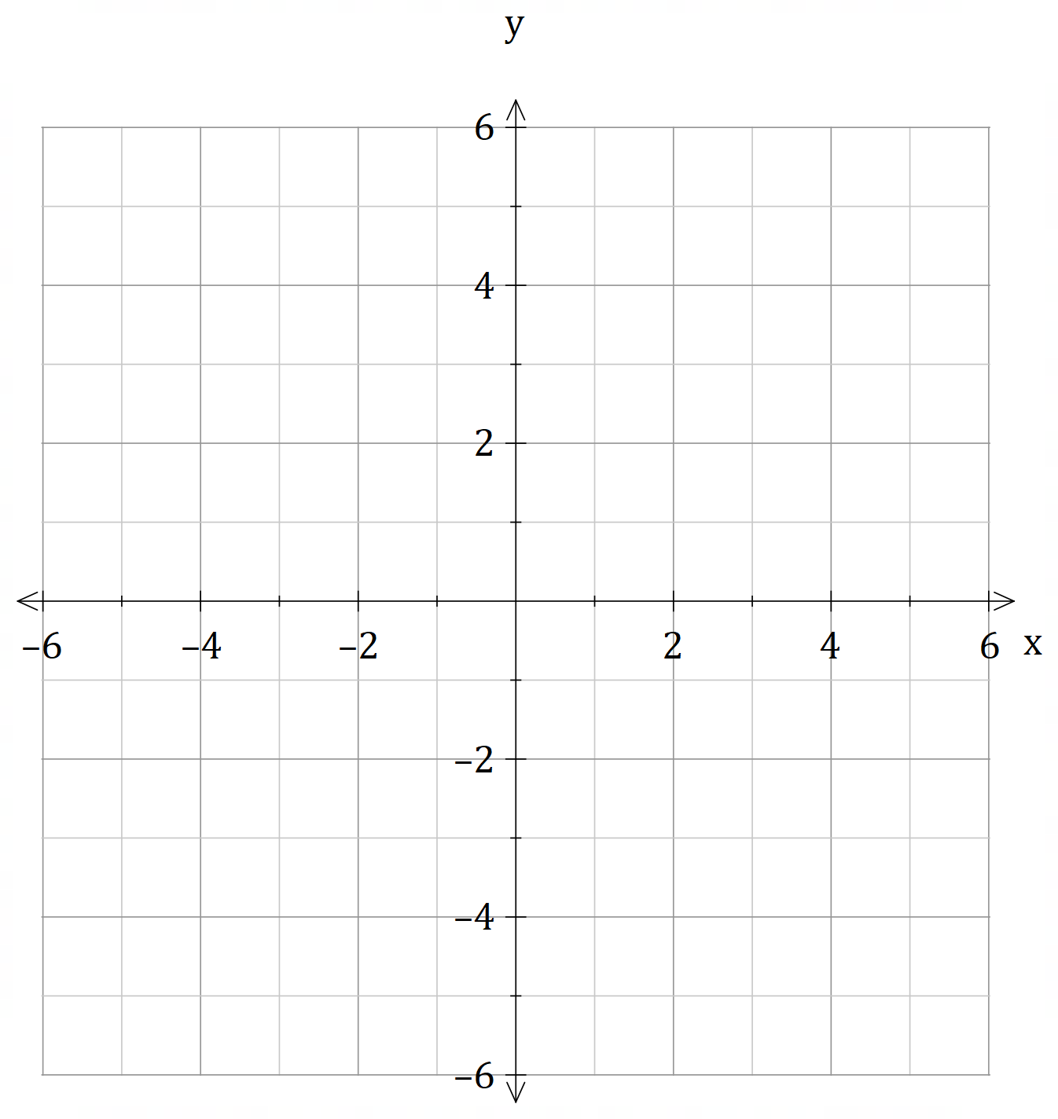

(c) Given that $f^{-1}\left(x\right)$ is a function, state its domain and range. (2 marks)

[the grid below is provided to assist your answer if needed]

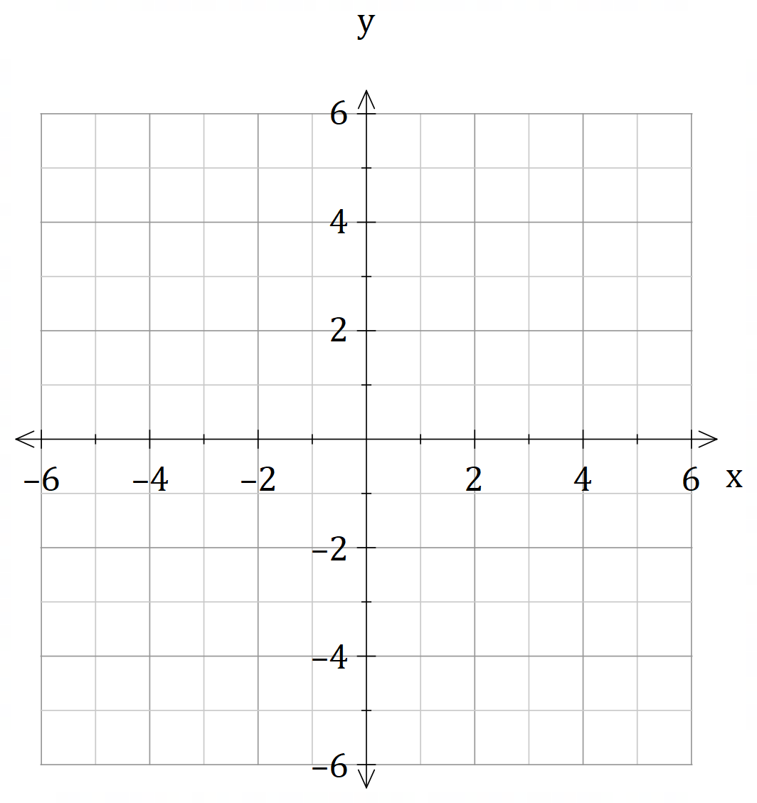

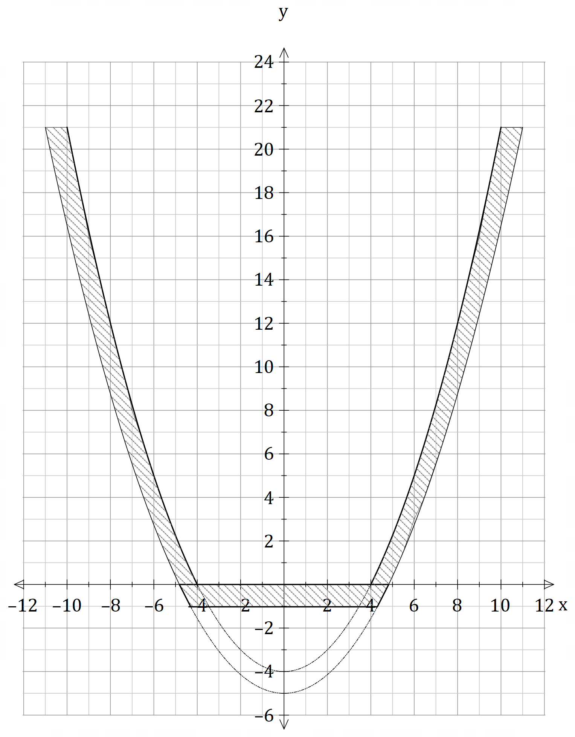**Question 7 (7 marks)**

A flower vase has a circular base of 8 cm in internal diameter, and a vertical height of 22 cm.

The cross-sectional outline of the vase resembles a parabola, such that the internal shape can be modelled by the graph shown.

The outer parabolic shapes are

modelled by $y=\frac{x^{2}}{4}-4$ and

$y=\frac{x^{2}}{5}-5$.

Every unit represents 1 cm.

$$4π\int_{0}^{21}{f\left(y\right)dy}$$

(a) The internal capacity of the vase is given by [cm3], where is a function

of the $y$ coordinate.

(i) Show that $f\left(y\right)=y+4$. (2 marks)

**(Question 7 – Continued)**

(a) (ii) Determine the exact capacity of the vase. (2 marks)

(b) Write an expression that would give the volume of material used to create the vase.

Do not evaluate your expression. (3 marks)

**Question 8 (4 marks)**

The velocity $v=\frac{dx}{dt}$ and acceleration $a=\frac{dv}{dt}$ are obtained for a particle with position $x\left(t\right)$ for

any time $t$.

(a) Multiply $a$ by $1=\frac{dx}{dx}$ to show that $a=v\frac{dv}{dx}$. (1 mark)

(b) The velocity $v$ and position $x$ of a particle are related by the equation $4x^{2}-v^{2}=1$.

Find an expression for the acceleration of the particle in terms of its position. (3 marks)

**End of Questions**

**Additional working space**

Question number(s): ……………………

**Additional working space**

Question number(s): ……………………